Installing PCAnyWhere 12.0 Application

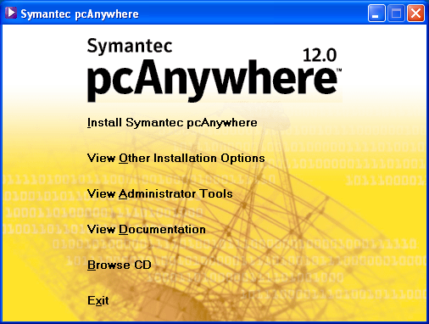

- Place CD Rom in Drive
- [Click] Install Symantec PCAnyWhere
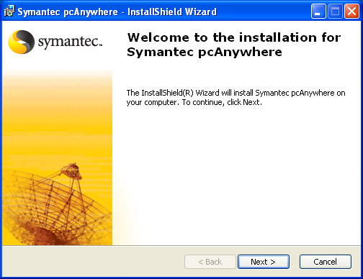

1) [Click] Next
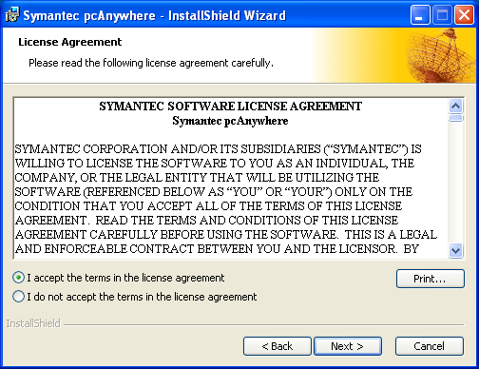
1) [Click] I accept the terms in the license agreement
2) [Click] Next

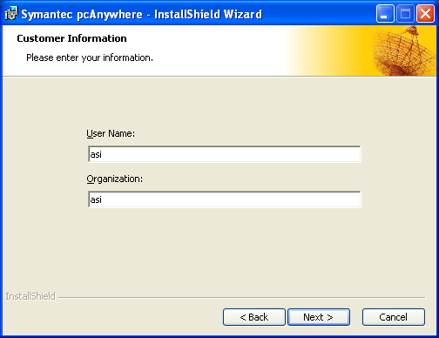

- Enter User Name and Organization name
- [Click] Next
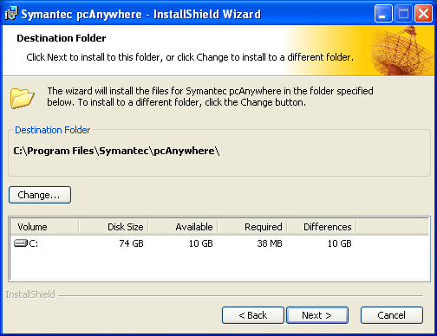

1) [Click] Next

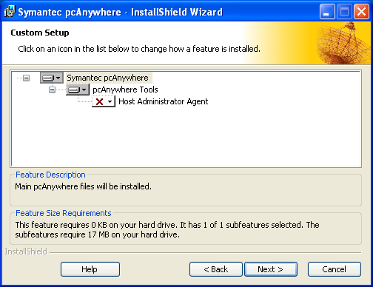

1) [Click] Next
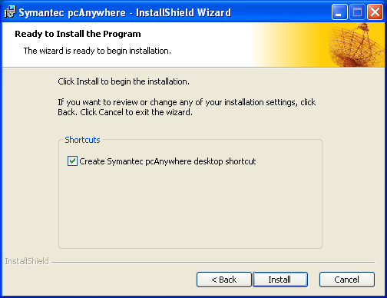

- [Click] Install

Setting up for a Host Connection

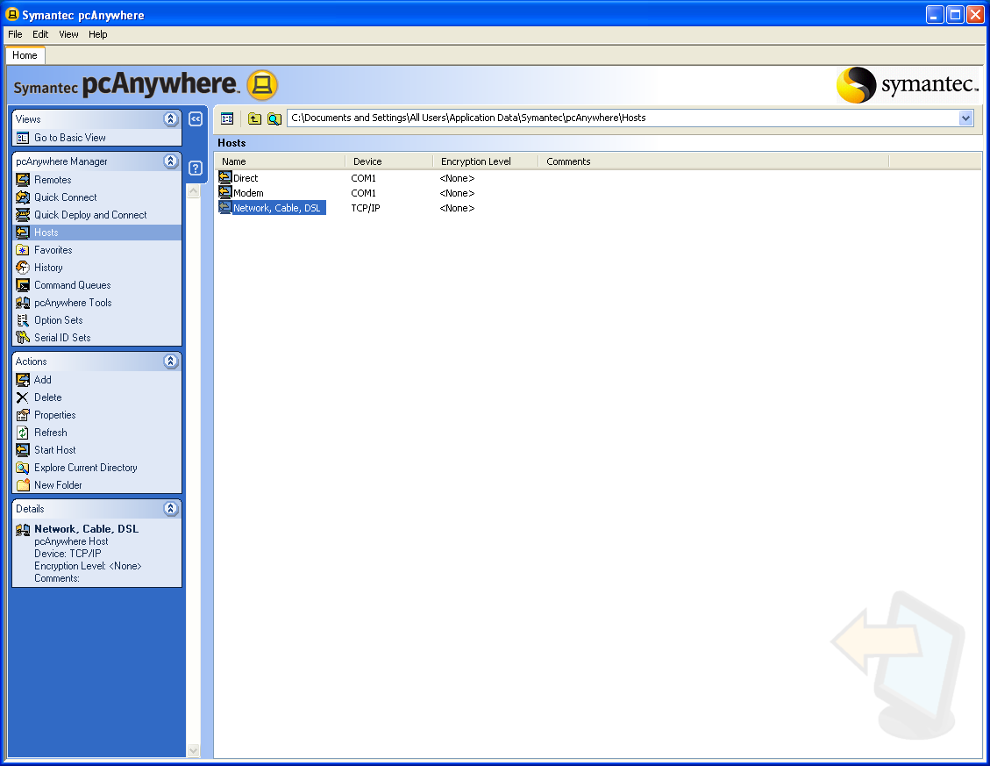

- [Click] on Host on the left side of the screen
- Right mouse click on Network cable DSL on the right side

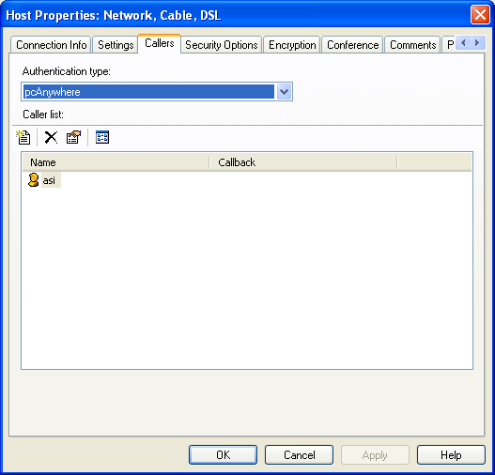

- [Click] on the callers tab
- [Click] on the paper icon on the left side of the screen (New item)
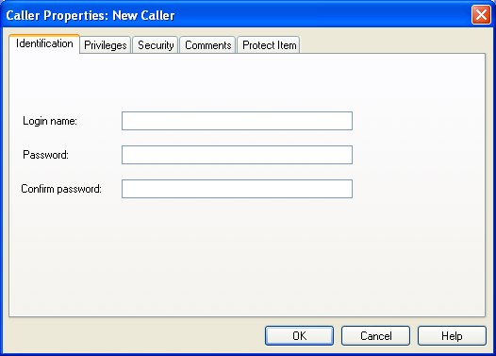

- Add a user name and password for the new connection this information comes from the Host computer.
- Confirm password and then click [OK]

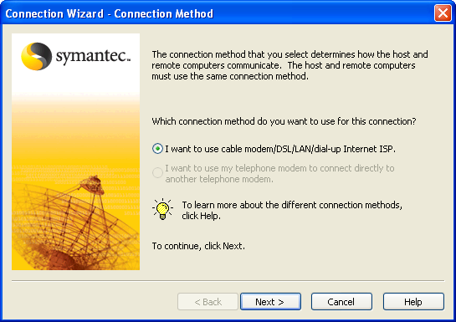

1) [Click] next to make the changes to the profile

Setting up a Remote connection to another computer using wizard

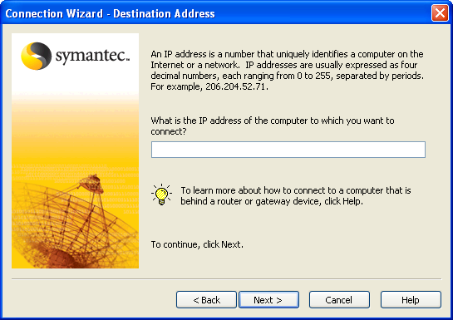

1) Enter IP address of the computer you will connect to

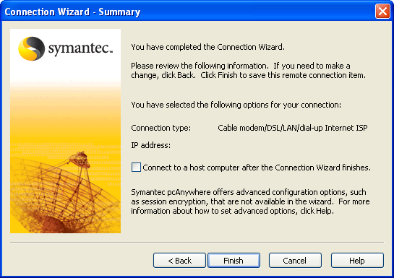

Setting up a Remote connection using properties of the icon

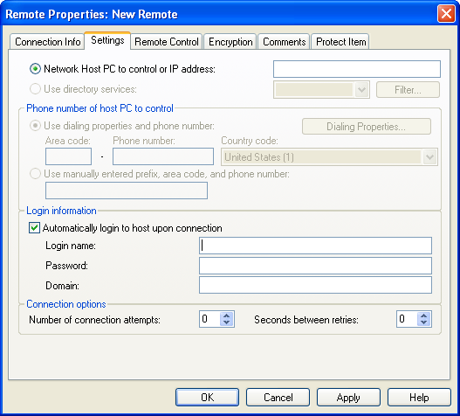

- [Click] on icon and go to properties
- [Click] setting tab
- Add the IP number of the computer you are connecting to
- Check off Automatically login to host upon connection
- Enter the login name
- Enter the password
- Enter the Domain in applicable
- [Click] Apply
- [Click] OK

- Double click the icon that you setup and it should make connection to the Host computer if all the settings are correct.

Note: All the above information comes from the Host computer when setting up this screen on your computer.

